**Experiment 2.1**

**Support Vector Machine**

**Student Name: SANSKAR AGRAWAL UID:20BCS5914**

**Branch: CSE Section/Group:20BCS_MM_806-B**

**Semester: 5th**

**Subject Name: Machine Learning Lab Subject Code: CSP-317**

1. **Aim/Overview of the practical:**

Implement Support Vector Machine on any data set and analyze the accuracy with Logistic regression

1. **Source Code:**

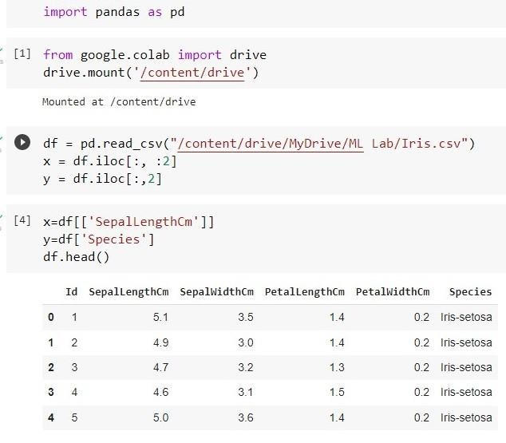

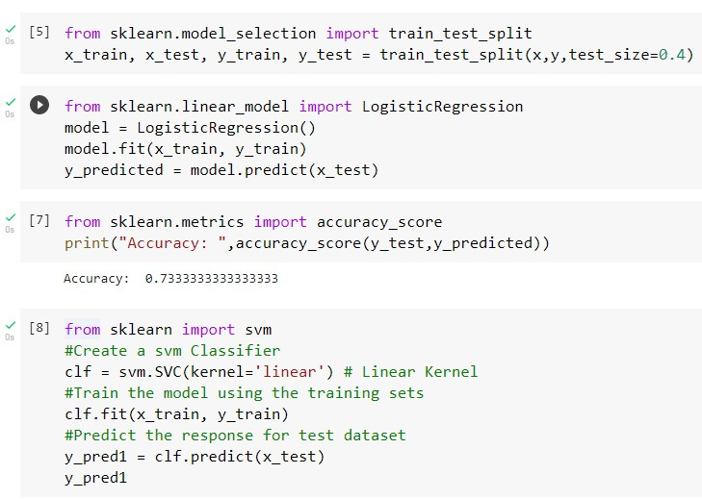

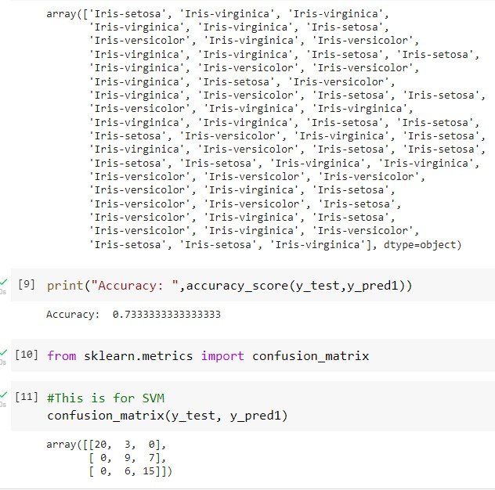

**Learning outcomes (What I have learnt):**

* 1. Learn about the Logistic regression algorithm
  2. Learn to perform the Logistic regression algorithm on iris dataset
  3. Learnt about the exploratory data analysis
  4. Learn to optimize the Model
  5. Got the clear concept of logistic regression classifier

**Evaluation Grid :**

|  |  |  |  |
| --- | --- | --- | --- |
| **Sr. No.** | **Parameters** | **Marks Obtained** | **Maximum Marks** |
| **1.** | **Student Performance (Conduct of experiment) objectives/Outcomes.** |  | **12** |
| **2.** | **Viva Voce** |  | **10** |
| **3.** | **Submission of Work Sheet (Record)** |  | **8** |
|  | **Total** |  | **30** |